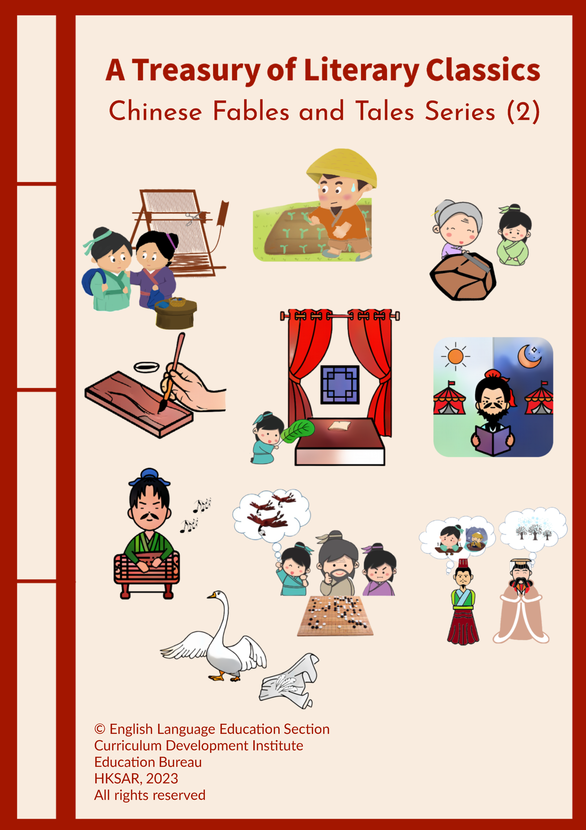

Questions
Chinese Fables and Tales Series (2)

China has a rich oral tradition with fables and tales passed down through thousands of years. Chinese fables and tales are timeless literary treasures. Some of these stories illustrate Chinese idioms based on classical Chinese literature, ancient history and myths, and are often closely linked to morals and values deeply rooted in Chinese culture, such as gratitude, perseverance, diligence, filial piety, empathy and respect for others.

Similar to the Chinese Fables and Tales Series released earlier, this series comprises a selection of ten inspirational Chinese stories written in English. Each story presents a well-known Chinese idiom or saying. Questions are set to enable students to develop their reading skills, enhance their mastery of various language items and reflect on the moral lesson of each story. As an extension activity, students are encouraged to watch a video* recommended in each story to give them a glimpse into the time-honoured traditions and culture as well as the latest development and achievements of China.

To facilitate students’ self-directed learning, an e-version of the series with appropriate interactive features such as answer-checking functions and prompts is provided. It is recommended that teachers read some of these captivating stories with their students to increase their motivation and encourage them to apply positive and proper values in their daily lives through respecting and caring for the people and things around them. Students may also read other Chinese fables and tales written in Chinese or English and learn the positive and proper values and profound wisdom embedded in them.

Suggested Stories for Key Stages 1 and 2  - Fanning the Pillow and Warming the Quilt  - Grinding an Iron Rod into a Needle  - Pulling up the Crops to Help Them Grow  - Putting Yourself in Someone’s Shoes  - Whole-hearted Devotion | Suggested Stories for Key Stage 2  - Gaining New Insights from Reviewing Old Knowledge  - Going Three-tenths of an Inch into the Wood  - Holding a Book in the Hand All the Time  - Quitting Halfway  - Sending Goose Feathers from Thousands of Miles Away
According to the level of difficulty of the ten stories, about half of them are suitable for both lower and upper primary students and the other half are more suitable for upper primary students:

Teachers may recommend or select the stories with reference to their students’ needs and abilities to cater for learner diversity.
*We are grateful to The China Current for the use of the videos on their website https://chinacurrent.com/.

English Language Education Section
Curriculum Development Institute
Education Bureau
The Hong Kong Special Administrative Region

12/F, Wu Chung House, 213 Queen’s Road East, Wan Chai, Hong Kong

Published 2023

The copyright of the materials in this series, other than the videos recommended in the Extension Activity, belongs to the Education Bureau of the Hong Kong Special Administrative Region.

Duplication of materials in this series other than the videos recommended in the Extension Activity is restricted to non-profit-making educational purposes only. In all cases, proper acknowledgements should be made. Otherwise, all rights are reserved, and no part of these materials may be reproduced, stored in a retrieval system, or transmitted in any form or by any means without the prior permission of the Education Bureau of the Hong Kong Special Administrative Region.

© 2023

Contents

Introduction | i

Key Stages 1 and 2 (Primary 1 to 6)

- Fanning the Pillow and Warming the Quilt | 1
- Grinding an Iron Rod into a Needle | 7
- Pulling up the Crops to Help Them Grow | 13
- Putting Yourself in Someone’s Shoes | 19
- Whole-hearted Devotion | 25

Key Stage 2 (Primary 4 to 6)

- Gaining New Insights from Reviewing Old Knowledge | 31
- Going Three-tenths of an Inch into the Wood | 37
- Holding a Book in the Hand All the Time | 43
- Quitting Halfway | 49
- Sending Goose Feathers from Thousands of Miles Away | 55

Read the Chinese story and answer the following questions.

Fanning the Pillow and Warming the Quilt

- This story is one of the 24 tales of filial piety in ancient China.

2. In the Eastern Han Dynasty*, there was a boy named Huang Xiang. His family was very poor. When he was at the age of nine, his mother passed away due to illness. He was brought up by his father, who worked very hard from day to night to earn a living. “My mother taught me to be a good boy. She was one of the kindest persons in the world, and I will always miss her. I will try my best to take care of my father,” Huang Xiang said to himself.

3. In order to give his father more time to rest, Huang Xiang always did most of the housework though he was only a young kid. In summer, the weather was very hot. Huang Xiang was afraid that his father would be too hot to sleep and bitten by mosquitoes, so he used a fan to cool his father’s pillow and bed and drive away the mosquitoes. When it was cold in winter, Huang Xiang crawled into his father’s bed and used his body to warm the quilt and the mattress before letting him sleep. His actions brought tears to his father’s eyes. “My dear son, you are so caring! I am so lucky to have you as my son!” said Huang Xiang’s father. The story about Huang Xiang’s behaviour soon spread throughout the village, and the villagers praised him as the role model.

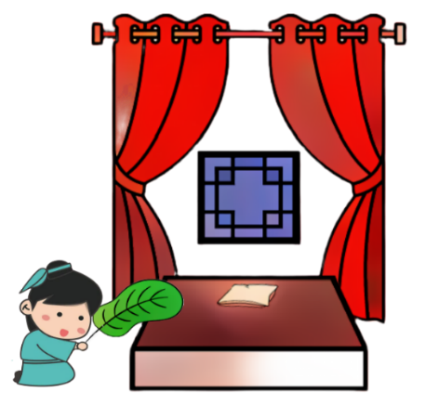
4. Huang Xiang understood that he had to provide his father with a better living condition, so he studied very hard. When he grew up, he became an important official and excelled in both military and administrative affairs. When he was serving as an official of the State of Wei, he gave his savings to help his people in a severe flood. “How kind Huang Xiang is to give his own savings to help his people!” the people exclaimed. Huang Xiang was loved by his people and they praised him as the greatest official.

*The Eastern Han Dynasty refers to a dynasty in ancient Chinese history that ruled from 25 AD to 220 AD.
- When did Huang Xiang’s mother die?
- She died when Huang Xiang was nine years old.
- She died when Huang Xiang was nineteen years old.
- She died when Huang Xiang became an official.
- She died when Huang Xiang’s father went out to work.
Explanation/Hints:
Read paragraph 2.
“When he was at the age of nine, his mother passed away due to illness.”

- In paragraph 2, what did Huang Xiang promise to himself?
- He promised to start working to earn a living.
- He promised to teach other people.
- He promised to take care of himself only.
- He promised to look after his father.
Explanation/Hints:
Read paragraph 2.
“ ‘My mother taught me to be a good boy. She was one of the kindest persons in the world, and I will always miss her. I will try my best to take care of my father,’ Huang Xiang said to himself.”

- What did Huang Xiang do for his father?
- He went to work to earn money.
- He did most of the housework for his father.
- He killed all the mosquitoes for his father.
- He gave his father a fan to cool the bed.
Explanation/Hints:
Read paragraph 3.
“In order to give his father more time to rest, Huang Xiang always did most of the housework though he was only a young kid.”

- How did Huang Xiang cool his father’s bed?
- He used a fan to cool his father’s bed.
- He crawled into his father’s bed to cool the quilt.
- He slept in his father’s bed and let the mosquitoes bite him.
- He bought a new mattress for his father.
Explanation/Hints:
Read paragraph 3.
“Huang Xiang was afraid that his father would be too hot to sleep and bitten by mosquitoes, so he used a fan to cool his father’s pillow and bed and drive away the mosquitoes.”

- How did Huang Xiang’s father think about his son’s behaviour?
- His father was sad.
- His father was shocked.
- His father was touched.
- His father was worried.
Explanation/Hints:
Read paragraph 3.
“His actions brought tears to his father’s eyes. ‘My dear son, you are so caring! I am so lucky to have you as my son!’ said Huang Xiang’s father.”

- What did the villagers think about Huang Xiang’s behaviour?
- They thought Huang Xiang was a poor boy.
- They thought Huang Xiang was a good boy.
- They thought Huang Xiang was a young boy.
- They thought Huang Xiang was a timid boy.
Explanation/Hints:
Read paragraph 3.
“The story about Huang Xiang’s behaviour soon spread throughout the village, and the villagers praised him as the role model.”

- Superlative adjectives are adjectives used in comparisons to describe something as being of the highest degree of a quality. We use superlative adjectives when making comparisons of three or more people or objects. The words “the slowest” and “the fastest” are examples of superlative adjectives.

Read the following descriptions. Fill in each blank with a superlative adjective from the list given. Each option can be used once only.

- luckiest B. greatest C. smartest D. kindest

 | Description | Superlative adjective
7a. | Huang Xiang would never forget his mother because she was the _____________ person in the family. | ( )
7b. | Huang Xiang’s father thought that he was the ____________ father because his son was so caring. | ( )
7c. | Huang Xiang excelled in both military and administrative affairs. He was one of the ____________ officials of the State of Wei. | ( )
7d. | Because of Huang Xiang’s generous actions, all the people of the State of Wei praised him as the _____________ official. | ( )

Explanation/Hints:
Read the sentences carefully to understand their meanings.

- Why did Huang Xiang study hard?
- He wanted to earn as much money for his father as possible.
- He wanted to become a rich official when he grew up.
- He wanted to provide his father with a better living condition.
- He wanted to please the emperor with good academic results.
Explanation/Hints:
Read paragraph 4.
“Huang Xiang understood that he had to provide his father with a better living condition, so he studied very hard.”

- How did Huang Xiang help his people when there was a severe flood?
- He did the housework for his people.
- He gave his people some fans to cool the house.
- He asked his people to pay more tax.
- He gave his savings to help his people.
Explanation/Hints:
Read paragraph 4.
“When he was serving as an official of the State of Wei, he gave his savings to help his people in a severe flood.”

- What is the moral lesson of the story? Based on the story, which Chinese saying can you think of?

Extension Activity

Watch the video clip “Sharing a Meal with Those We Love”, which is about people returning home from different parts of the world during Chinese New Year to share a meal with their loved ones. The video also emphasises that the family are the people who make us feel safe, and we need to show our respect and love.

https://chinacurrent.com/story/20872/sharing-a-meal-with-those-we-love

Do you care about your grandparents, parents or family members? How do you show your love and care to them during Chinese New Year and other Chinese festivals? Think and share your ideas or experiences with your parents or classmates.

Read the Chinese story and answer the following questions.

Grinding an Iron Rod into a Needle

1. Li Bai was a great poet in the Tang Dynasty*. However, he was lazy and afraid of difficulties when he was a young boy. He did not like to study and always ran out to play without finishing his homework. Being absent-minded in class, he made slow progress in his studies.

2. One day, Li Bai met an old woman near a riverbank when he was on his way home. She was grinding a very thick iron rod on a rock. Driven by curiosity, he asked the old woman at once. “Why are you grinding this iron rod? It is thick and hard!”

3. “I want to turn this thick rod into a needle,” replied the old woman.

4. Li Bai’s jaw dropped. He asked, “How can you turn such a thick iron rod into a needle? This would take many years!”

5. “This doesn’t matter. If I am willing to put my effort and continue to work very hard, I will be able to turn it into a fine needle!” The old woman chuckled and answered confidently.

6. Deeply moved by what the old woman had said, Li Bai felt ashamed and made up his mind to study hard since then. With his determination, he accomplished many difficult tasks and made great progress in his schoolwork. He finally became one of the greatest poets in Chinese history. Many of his poems were compiled in the anthology Three Hundred Tang Poems.

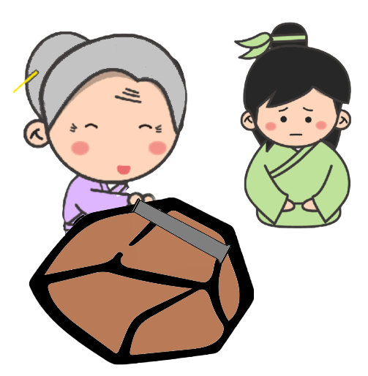

*The Tang Dynasty refers to a dynasty in ancient Chinese history that ruled from 618 AD to 907 AD.

1. What did Li Bai not like to do when he was young?
a. He did not like to study.
b. He did not like to play.
c. He did not like to be lazy.
d. He did not like to run.
Explanation/Hints:
Read paragraph 1.
“However, he was lazy and afraid of difficulties when he was a young boy. He did not like to study and always ran out to play without finishing his homework.”

2. Which of the following adjectives best describes Li Bai when he was in class?
a. Curious
b. Active
c. Inattentive
d. Impatient
Explanation/Hints:
Read paragraph 1.
“Being absent-minded in class, he made slow progress in his studies.”

- Read paragraph 2. What was the old woman doing?
a. The old woman was looking for a needle.
b. The old woman was breaking an iron rod.
c. The old woman was cooking some food.
d. The old woman was grinding an iron rod.
Explanation/Hints:
Read paragraph 2.
“She was grinding a very thick iron rod on a rock.”

- In paragraph 2, why did Li Bai ask the old woman a question?
a. Li Bai was eager to make friends with the old woman.
b. Li Bai was interested in knowing what the old woman was doing.
c. Li Bai was worried about the old woman’s safety.
d. Li Bai was keen to offer a helping hand to the old woman.
Explanation/Hints:
Read paragraph 2.
“Driven by curiosity, he asked the old woman at once.”

5. How did Li Bai feel when he knew that the old woman wanted to turn an iron rod into a needle?
a. He was excited and wanted to learn the skills.
b. He was curious and wanted to know the reasons.
c. He was shocked and could not believe what he heard.
d. He was upset about how confident the old woman was.
Explanation/Hints:
Read paragraph 4.
“Li Bai’s jaw dropped. He asked, ‘How can you turn such a thick iron rod into a needle? This would take many years.’ ”

6. According to the old woman, how would she achieve her goal?
a. She would keep grinding the iron rod in order to turn it into a needle.
b. She would study hard to find out how to grind an iron rod into a needle.
c. She would ask Li Bai many questions to learn how to grind an iron rod.
d. She would ask Li Bai to help her turn an iron rod into a needle.
Explanation/Hints:
Read paragraph 5.
“ ‘This doesn’t matter. If I am willing to put my effort and continue to work very hard, I will be able to turn it into a fine needle!’ ”

- Antonyms are words with opposite meanings. For example, “bad” is an antonym of “good”.
Read the following descriptions. Turn each of the underlined words into the opposite meaning by choosing an adjective from the list given. Each option can be used once only.

A. hard-working B. old C. fine D. focused

 | Description | Adjective
7a. | When Li Bai was young, he was lazy. However, he became _________ after talking with the old woman. | ( )
7b. | Li Bai was absent-minded when he was in class. He was very __________ in his studies after he made up his mind. | ( )
7c. | When Li Bai was young, he was afraid of difficulties. In contrast, the woman was determined to overcome her difficulties even though she was __________. | ( )
7d. | Li Bai was motivated by how determined the old woman was in turning a thick rod into a __________ needle. | ( )

Explanation/Hints:
Read the sentences carefully to understand their meanings.

8. How did Li Bai feel after talking with the old woman?
a. He was afraid.
b. He was absent-minded.
c. He was worried.
d. He was ashamed.
Explanation/Hints:
Read paragraph 6.
“Deeply moved by what the old woman had said, Li Bai felt ashamed and made up his mind to study hard since then.”

9. What did Li Bai become when he grew up?
a. He became a Chinese historian.
b. He became a Chinese teacher.
c. He became a great poet.
d. He became a brave soldier.
Explanation/Hints:
Read paragraph 6.
“With his determination, he accomplished many difficult tasks and made great progress in his schoolwork. He finally became one of the greatest poets in Chinese history.”

10. What is the moral lesson of the story? Based on the story, which Chinese saying can you think of?

Extension Activity

Watch the video clip “Paper that Takes Years to Make”, which is about the process of making paper developed over the centuries in China and recognised as a cultural treasure by the United Nations Educational, Scientific and Cultural Organisation (UNESCO).

https://chinacurrent.com/story/20245/paper-that-takes-years-to-make

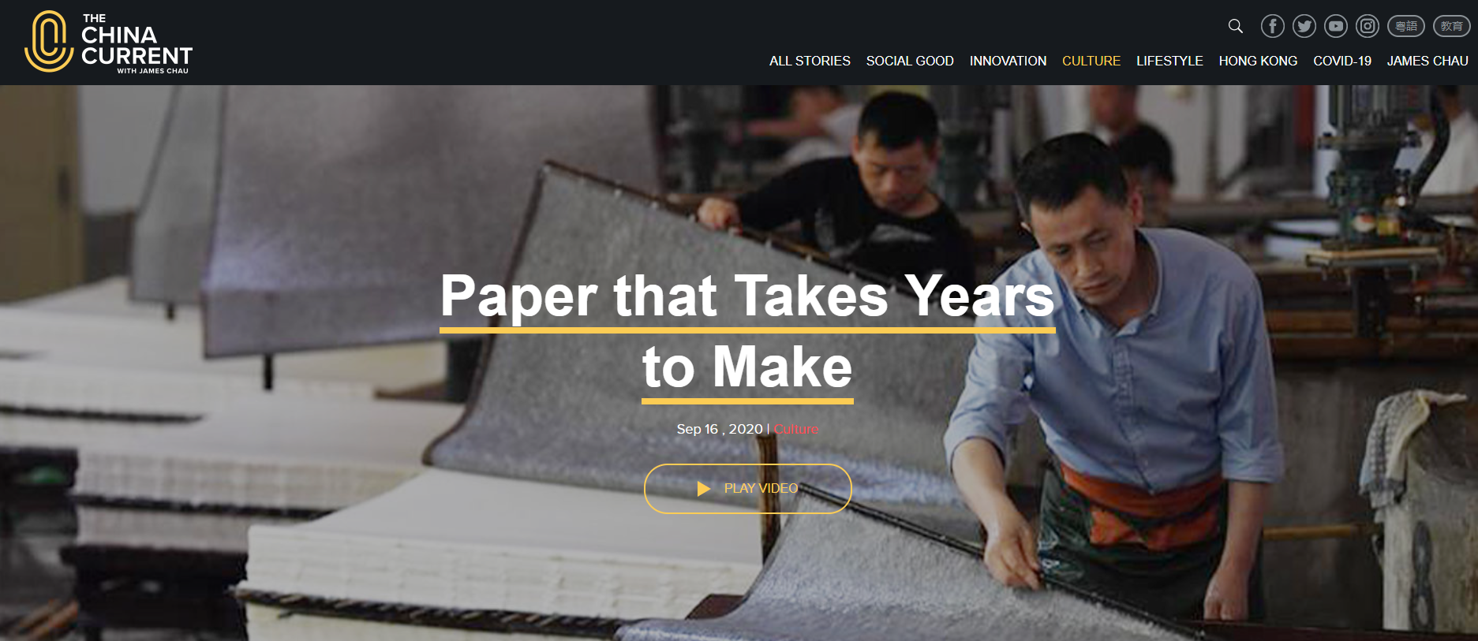

People put a lot of time and effort into making quality rice paper. What have you learnt from them? What should we do to overcome difficulties and achieve our goals? Think and share your ideas or experiences with your parents or classmates.

Read the Chinese story and answer the following questions.

Pulling up the Crops to Help Them Grow

1. Once upon a time, there was a farmer who was worried about how slowly his crops grew. He went to his field every day to check his crops and found that they still grew very slowly, not as quickly as he expected. The more he watched, the less patient he became. Feeling very frustrated, he wondered how the crops could grow faster until one day he came up with an idea.

2. The farmer rushed to the field excitedly, bent down, and one by one pulled all the crops up an inch. He was as busy as a bee. He felt very tired at the end of the day. Nevertheless, he thought that his hard work would pay off. He noticed that all his crops were taller than before. “What a wonderful idea! Look, how much taller the plants have grown!” he said.

3. With great satisfaction, the farmer went back home and told his family what he had done. “I worked for the whole day. How exhausted I am now! But all my crops in the field have grown a lot taller.”

4. When the family heard this, they were stunned and speechless. They hurried to the field immediately. However, it was already too late. The farmer and his family were heartbroken to see that all the crops were dead. All the villagers learnt about the incident and felt sorry about it. The farmer finally blamed himself for being so stupid.

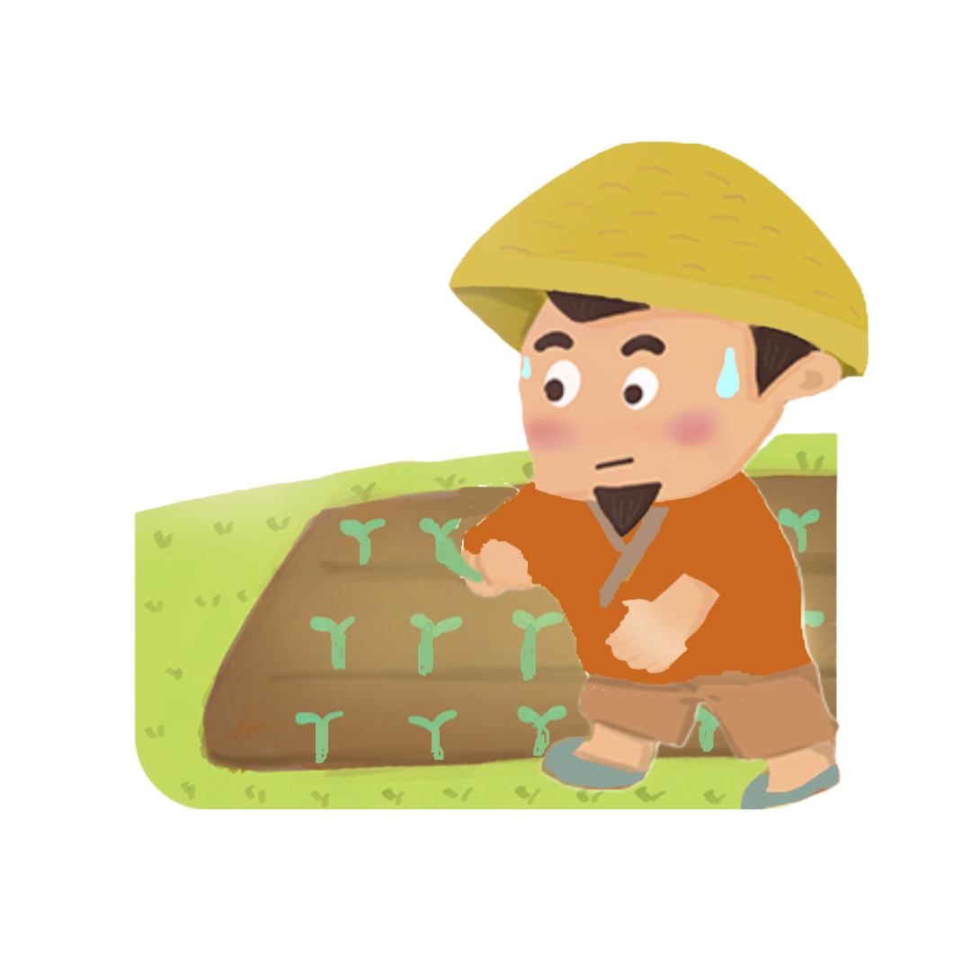
1. How did the farmer feel when his crops grew very slowly?
a. He was exhausted.
b. He was satisfied.
c. He was worried.
d. He was patient.
Explanation/Hints:
Read paragraph 1.
“Once upon a time, there was a farmer who was worried about how slowly his crops grew.”

2. What did the farmer want to do with the crops?
a. He wanted to make the crops grow faster.
b. He wanted to make the crops grow greener.
c. He wanted to harvest all the crops.
d. He wanted to plant new crops.
Explanation/Hints:
Read paragraph 1.
“Feeling very frustrated, he wondered how the crops could grow faster until one day he came up with an idea.”

3. What did the farmer do when he rushed to the field?
a. He burned all the crops.
b. He pulled all the crops up.
c. He watered all the crops.
d. He buried all the crops.
Explanation/Hints:
Read paragraph 2.
“The farmer rushed to the field excitedly, bent down, and one by one pulled all the crops up an inch.”

4. What did the farmer notice about his crops after he pulled them up?
a. He noticed that his crops had grown with flowers.
c. He noticed that some crops had been dead.
d. He noticed that his crops had grown greener.
d. He noticed that his crops had grown taller.
Explanation/Hints:
Read paragraph 2.
“He noticed that all his crops were taller than before.”

5. The farmer told _______________ about the pulling of the crops.
a. another farmer
b. his parents
c. his villagers
d. his family
Explanation/Hints:
Read paragraph 3.
“With great satisfaction, the farmer went back home and told his family what he had done.”

6. What did the family do after knowing what the farmer had done to the crops?
a. The family rushed to the field at once.
b. The family pulled all the crops up.
c. The family thought that the idea was wonderful.
d. The family blamed the farmer at once.
Explanation/Hints:
Read paragraph 4.
“When the family heard this, they were stunned and speechless. They hurried to the field immediately.”

7. Similes are figures of speech that compare different things using words such as “as” or “like”, for example “as bright as a button” or “sing like an angel”.

Read the following descriptions. Fill in each blank with a simile from the list given. Each option can be used once only.

A. as pale as a white sheet B. as busy as a bee
C. as wise as an owl D. as easy as pie

 | Description | Simile
7a. | The farmer thought that making the crops grow fast was ___________. | ( )
7b. | The farmer was ___________. He was very tired after pulling all the crops up. | ( )
7c. | The farmer’s face was ___________ when he saw the dead crops. | ( )
7d. | The farmer blamed himself for being so stupid. He promised himself that he would learn to be ___________. | ( )

Explanation/Hints:
Read the sentences carefully to understand their meanings.

8. How did his family think about the farmer?
a. His family thought that the farmer was clever.
b. His family thought that the farmer was stupid.
c. His family thought that the farmer was hard-working.
d. His family thought that the farmer was cunning.
Explanation/Hints:
Read paragraph 4.
“When the family heard this, they were stunned and speechless. They hurried to the field immediately. However, it was already too late.”

9. What happened to all the crops in the end?
a. All the crops grew taller.
b. All the crops grew greener.
c. All the crops were dead.
d. All the crops were buried.
Explanation/Hints:
Read paragraph 4.
“However, it was already too late. The farmer and his family were heartbroken to see that all the crops were dead.”

10. What is the moral lesson of the story? Based on the story, which Chinese saying can you think of?

Extension Activity

Watch the video clip “How Hundreds of Millions of People Learned to Read and Write”, which is about how China’s education system has helped millions of children to catch up with the rest of the world.

https://chinacurrent.com/story/19103/how-hundreds-of-millions-of-people-learned-to-read-and-write

Education can improve people’s lives. Some parents nowadays arrange extra training courses for their children in the hope that they could be ahead of the other children. What opinions would you give to these parents? As a student, what are your responsibilities in your schoolwork? Think and share your ideas or experiences with your parents or classmates.

Read the Chinese story and answer the following questions.

Putting Yourself in Someone’s Shoes

1. During the Spring and Autumn Period*, in the State of Qi, there was a high official called Yan Ying. He was smart and cared about the livelihood of people.

2. In a cold winter, it had been snowing heavily for three days and three nights. Duke Jing of Qi was wearing a long thick coat and enjoying the scenery of snow in the hall of his house. “How wonderful it is! I really hope that it will continue to snow for a few more days. The scenery would be even more beautiful,” exclaimed Duke Jing of Qi loudly. He forgot that poor people might suffer a lot from the severe cold.

3. At that moment, Yan Ying came in and looked worriedly at the snow. Duke Jing of Qi said to Yan Ying, “This year, the weather is very strange. It has been snowing for three days but it is still not cold at all. It is just like springtime!” Yan Ying saw Duke Jing of Qi wearing a long thick coat in his comfortable house. “Is it really not cold at all?” he asked. Duke Jing of Qi nodded his head and replied, “I’m not a three-year-old kid. Do you think I can’t tell when it’s hot or cold?”

4. Yan Ying knew that Duke Jing of Qi did not understand why he asked the question, so he said directly, “In ancient times, wise rulers thought about people who were hungry, cold and tired when they themselves were full, warm and comfortable. We should remember the people in need.” Duke Jing of Qi was speechless. He felt ashamed and immediately gave away food and clothes to those who were hungry and cold.

5. People who have love and concern for others will always put themselves in other people’s shoes. They will think of other people’s feelings and render help.
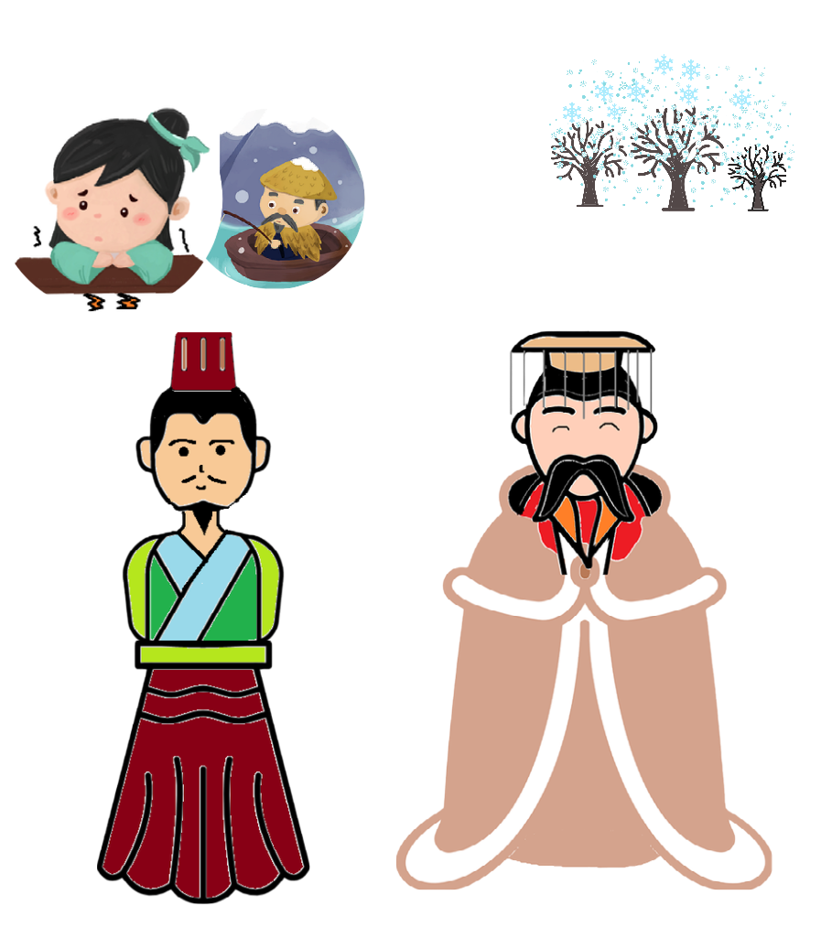

*The Spring and Autumn Period refers to a period of time (770 BC to 476 BC) in ancient Chinese history characterised by instability.
1. Yan Ying was a ___________ official of the State of Qi.
a. caring
b. brave
c. self-centred
d. hard-working
Explanation/Hints:
Read paragraph 1.
“He (Yan Ying) was smart and cared about the livelihood of people.”

2. Read paragraph 2. What do you think about Duke Jing of Qi? He was ___________.
a. caring
b. brave
c. self-centred
d. hard-working
Explanation/Hints:
Read paragraph 2.
“ ‘How wonderful it is! I really hope that it will continue to snow for a few more days. The scenery would be even more beautiful,’ exclaimed Duke Jing of Qi loudly. He forgot that poor people might suffer a lot from the severe cold.”

3. Duke Jing of Qi thought the weather was like ___________ though it was snowy outside.
a. spring
b. summer
c. autumn
d. winter
Explanation/Hints:
Read paragraph 3.
“Duke Jing of Qi said to Yan Ying, ‘This year, the weather is very strange. It has been snowing for three days but it is still not cold at all. It is just like springtime!’ ”

4. Why did Duke Jing of Qi say it was not cold at all?
a. He thought it did not snow heavily.
b. He was strong and always felt hot in winter.
c. He could not tell when it was hot or cold.
d. He was staying indoors and wearing a thick coat.
Explanation/Hints:
Read paragraph 3.
“Yan Ying saw Duke Jing of Qi wearing a long thick coat in his comfortable house.”

5. Duke Jing of Qi was ___________ when he said “I’m not a three-year-old kid. Do you think I can’t tell when it’s hot or cold?”
a. delighted
b. proud
c. puzzled
d. excited
Explanation/Hints:
Was Duke Jing of Qi happy to answer Yan Ying’s question?
Did he feel proud of being able to tell when it was hot or cold?
Did he know why Yan Ying asked such a question?

6. Read paragraph 4. Which of the following is correct?
a. Duke Jing of Qi thought Yan Ying was not a kind person.
b. Duke Jing of Qi understood why Yan Ying asked him the question.
c. Duke Jing of Qi did not understand Yan Ying’s advice.
d. Duke Jing of Qi cared for the needy people after listening to Yan Ying’s advice.
Explanation/Hints:
Read paragraph 4.
“He (Duke Jing of Qi) felt ashamed and immediately gave away food and clothes to those who were hungry and cold.”

- Adverbs are words which describe an action (e.g. She eats quickly.). We usually form an adverb by adding –ly to an adjective (e.g. careful carefully; beautiful beautifully), but some adverbs (e.g. early, late, fast) are the same as their adjective counterparts.

Read the following descriptions. Fill in each blank with an adverb from the list given. Each option can be used once only.

A. heavily B. immediately C. loudly D. directly

 | Description | Adverb
7a. | After listening to Yan Ying’s advice, Duke Jing of Qi gave away food and clothes __________ to the people in need. | ( )
7b. | Yan Ying told Duke Jing of Qi __________ that he should remember the people in need. | ( )
7c. | Although it had been snowing __________ for three days, Duke Jing of Qi still thought it was not cold at all. | ( )
7d. | Duke Jing of Qi said ______________, “It would be more beautiful if it snows for a few more days!” | ( )

Explanation/Hints:
Read the sentences carefully to understand their meanings.

8. How did Duke Jing of Qi feel after listening to Yan Ying’s advice? He was ___________.
a. proud
b. guilty
c. happy
d. excited
Explanation/Hints:
Read paragraph 4.
“ He (Duke Jing of Qi) felt ashamed and immediately gave away food and clothes to those who were hungry and cold.”

- What did Duke Jing of Qi give the needy people at the end?
He gave the needy people ________.
a. food only
b. clothes and shoes
c. clothes and food
d. shoes only
Explanation/Hints:
Read paragraph 5.
“He (Duke Jing of Qi) felt ashamed and immediately gave away food and clothes to those who were hungry and cold.”

10. What is the moral lesson of the story? Based on the story, which Chinese saying can you think of?

Extension Activity

Watch the video clip “Heroes One Year On | The Novel Outbreak”, which is about how the frontline workers served the people under lockdown in the Hubei province.

https://chinacurrent.com/story/20804/heroes-one-year-on-the-novel-outbreak

During the COVID-19 pandemic, many volunteer health workers, such as doctors and nurses, have helped save people’s lives unconditionally. How can we express our gratitude to them? Think and share your ideas or experiences with your parents or classmates.

Read the Chinese story and answer the following questions.

Whole-hearted Devotion

1. Once upon a time, there was a famous chess player named Yi Qiu. He was highly respected by people because of his superb chess skills in weiqi.

2. Many people wanted to become Yi Qiu’s students because of his brilliant skills. Once he was teaching two students the same skills in a class. One of the students listened to his words very carefully and had full concentration in class. The other student, who appeared to be listening, was in fact daydreaming. When he attended Yi Qiu’s class, he always looked at the fields outside the windows, and dreamed of shooting and catching wild geese which were flying in the sky. “If I have a bow and some arrows, I will shoot the wild geese and cook them. How wonderful!” thought the absent-minded student.

3. After a few months, Yi Qiu asked his two students to play a game of weiqi in order to see how well they learnt. In the first few rounds, the absent-minded student was in a leading position. However, he lost in the last few rounds because of his poor chess skills. On the other hand, the attentive student gradually fought back in a calm and thoughtful manner.

4. When Yi Qiu saw it, he advised the lazy student and said, “You need to practise hard and concentrate if you want to master the skills well.” Although the two students studied together and were taught by Yi Qiu at the same time, the dedicated student finally became a well-known chess master. Luckily, the absent-minded student learnt a lesson and was regretful. From then onwards, he tried very hard to improve his learning attitude.

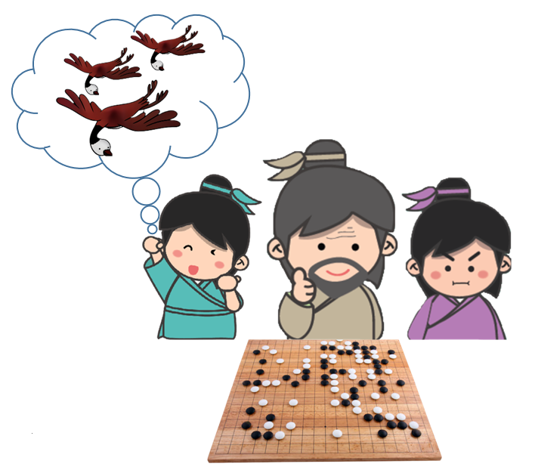
- What was Yi Qiu good at?
- He was good at playing weiqi.
- He was good at shooting.
- He was good at catching birds.
- He was good at making arrows.
Explanation/Hints:
Read paragraph 1.
“Once upon a time, there was a famous chess player named Yi Qiu. He was highly respected by people because of his superb chess skills in weiqi.”

- How did Yi Qiu teach the two students?
- He taught the students one after the other.
- He taught the two students the same skills.
- He taught more difficult skills to the clever student.
- He told the two students to play a chess game and then ask questions.
Explanation/Hints:
Read paragraph 2.
“Once he was teaching two students the same skills in a class.”

- Which of the following adjectives best describes the student who listened to Yi Qiu’s words?
- Playful
- Absent-minded
- Attentive
- Talkative
Explanation/Hints:
Read paragraph 2.
“One of the students listened to his words very carefully and had full concentration in class.”

- What did the other student do when he attended Yi Qiu’s class?
- He looked at the sky and daydreamed during lessons.
- He listened to Yi Qiu’s words carefully.
- He answered Yi Qiu’s questions eagerly.
- He shot the birds during lessons.
Explanation/Hints:
Read paragraph 2.
“When he attended Yi Qiu’s class, he always looked at the fields outside the windows, and dreamed of shooting and catching wild geese which were flying in the sky.”

- What tools would the absent-minded student use to catch the birds?
- He would use chess pieces.
- He would use a chess board.
- He would use a cooking knife.
- He would use a bow and some arrows.
Explanation/Hints:
Read paragraph 2.
“ ‘If I have a bow and some arrows, I will shoot the wild geese and cook them.’ ”

- How did Yi Qiu know about the learning performance of the two students?
- He asked the two students to take a chess test on paper.
- He asked the two students to talk about how to play chess.
- He asked the two students to play a chess game.
- He asked the two students to hand in a learning file.
Explanation/Hints:
Read paragraph 3.
“After a few months, Yi Qiu asked his two students to play a chess game in order to see how well they learnt.”

- The suffix “-ion” is added to the end of a word to form a different word class. For example, the verb “collect” is changed to the noun “collection” after the suffix “-ion” is added. When the suffix “-ion” is added after a word that ends with a silent letter “e”, the silent letter “e” has to be dropped. For example, the silent letter “e” is dropped after the verb “pollute” is turned into the noun “pollution”.

Read the following descriptions. Fill in each blank with a noun from the list given. Each option can be used once only.

- demonstration B. suggestion C. concentration D. reflection

 | Description | Noun
7a. | The attentive student had full ____________ in class, so he won the chess game. | ( )
7b. | Yi Qiu’s __________ of chess skills was clear and easy to understand. For this reason, the attentive student could master the skills well. | ( )
7c. | Yi Qiu asked the absent-minded student to pay more attention in class. However, he did not listen to Yi Qiu’s __________, so he lost the chess game. | ( )
7d. | In the end, the absent-minded student was sorry for his poor learning attitude. On__________, he decided to change and improve himself. | ( )

Explanation/Hints:
Read the sentences carefully to understand their meanings.

- Why did the absent-minded student lose the chess game?
- He ran away when he was playing the chess game.
- He did not concentrate and learnt far less than the other student.
- The other player took away the chess board.
- The other player could not master the chess skills well.
Explanation/Hints:
Read paragraphs 3 and 4.
“However, he lost in the last few rounds because of his poor chess skills. … ‘You need to practise hard and concentrate if you want to master the skills well.’ ”

- How did the attentive student play the chess game?
- He played the chess game slowly.
- He played the chess game carelessly.
- He played the chess game quickly.
- He played the chess game carefully.
Explanation/Hints:
Read paragraph 3.
“On the other hand, the attentive student gradually fought back in a calm and thoughtful manner.”

- What is the moral lesson of the story? Based on the story, which Chinese saying can you think of?

Extension Activity

Watch the video clip “My Journey from Poverty to College”, which is about how Elvis Cao, a young Chinese scholar in renewable energy and a PhD candidate at Cornell University, USA, has changed his fate, become knowledgeable and risen above poverty through perseverance and determination.

https://chinacurrent.com/story/20101/my-journey-from-poverty-to-college

What was the biggest dream for Elvis Cao in his childhood? What did he do to make his dream come true? What have you learnt from him? Think and share your ideas or experiences with your parents or classmates.

Read the Chinese story and answer the following questions.

Gaining New Insights from Reviewing Old Knowledge
1. Confucius (also known as Kongzi) was one of the greatest educators in the Spring and Autumn Period*. He was keen on music and got along well with a famous music player called Shi Xiang. One day, Confucius visited Shi Xiang. They discussed how they could improve the skills of playing the guqin, a plucked seven-string Chinese musical instrument. Shi Xiang could not hide his excitement and started to play the guqin. Listening to the music attentively, Confucius decided to learn this extraordinary piece of music from Shi Xiang.

2. Shi Xiang had never seen anyone like Confucius, who learnt with diligence and humility. Although Confucius mastered the guqin well, he was never satisfied. He practised the piece wholeheartedly. After a few weeks, Confucius was still practising the same piece. Shi Xiang said, “You are excellent in playing this piece. You can learn a new one now.” However, Confucius did not agree. He replied, “I can master the techniques now, but I still need more time to gain new insights. I would like to explore the richness of the music and the messages from the composer. After that, I will learn a new piece. Please allow me to practise for a few more days.”

3. One day, Confucius stood up amid the sound of the guqin and looked up at the sky. He said thoughtfully, “I have realised the character of the composer. I could feel his strength, his bright eyes and the courage to rule his country. He must be a far-sighted, gentle and honest king. Who else could compose such a great piece except for King Wen of Zhou?” Shi Xiang was very surprised and said, “Indeed! When my teacher taught me this piece, he said that the piece was called ‘Wen Wang Cao’, composed by King Wen of Zhou. I am so impressed that you have learnt the piece so deeply. You are truly remarkable!”

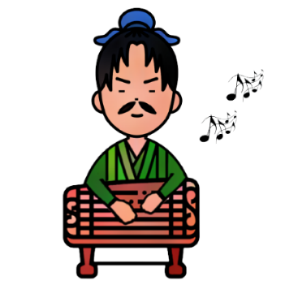
4. Confucius was always passionate about the pursuit of music. As a teacher, he was a good influence on his students. He encouraged them to study deeply to gain new insights.

*The Spring and Autumn Period refers to a period of time (770 BC to 476 BC) in ancient Chinese history characterised by instability.

1. In paragraph 1, what did Confucius and Shi Xiang talk about?
They talked about ________.
a. Shi Xiang’s accomplishment in music
b. Confucius’s diligence and humility
c. the skills in playing the guqin
d. the skills in repairing the guqin
Explanation/Hints:
Read paragraph 1.
“One day, Confucius visited Shi Xiang. They discussed how they could improve the skills of playing the guqin, a plucked seven-string Chinese musical instrument.”

2. What was the relationship between Confucius and Shi Xiang?
a. Confucius and Shi Xiang did not know each other.
b. Confucius and Shi Xiang were good friends.
c. Confucius and Shi Xiang were enemies.
d. Confucius and Shi Xiang were brothers in the same family.
Explanation/Hints:
Read paragraph 1.
“He was keen on music and got along well with a famous music player called Shi Xiang.”

3. How did Shi Xiang feel when he started to play the guqin?
Shi Xiang felt ________ when he started to play the guqin.
a. delighted
b. impressed
c. remarkable
d. surprised
Explanation/Hints:
Read paragraph 1.
“Shi Xiang could not hide his excitement and started to play the guqin.”

4. Choose the best adjective to describe Confucius when he was acquiring new knowledge.
a. Tired
b. Dreamy
c. Humble
d. Arrogant
Explanation/Hints:
Read paragraph 2.
“Shi Xiang had never seen anyone like Confucius, who learnt with diligence and humility.”

5. Read paragraph 2. Which of the following sentences is correct?
a. Confucius spent a few days practising the same piece of music only.
b. Shi Xiang thought it was time for Confucius to learn a new piece.
c. Confucius was very proud of his skills in playing the guqin.
d. Confucius did not want to learn a new piece any more.
Explanation/Hints:
Read paragraph 2 and consider the questions below.
How long had Confucius practised the piece?
What did Shi Xiang say to Confucius?
How did Confucius play the guqin?
Did Confucius want to learn a new piece? When?

6. Why did Confucius want to practise the piece of music for a few more days?
a. Confucius thought that he was not excellent in playing the piece.
b. Confucius was not bored and wanted to play the same piece forever.
c. Confucius did not like Shi Xiang and refused to learn a new piece at once.
d. Confucius was interested in the music and wanted to gain new insights.
Explanation/Hints:
Read paragraph 2.
“He replied, ‘I can master the techniques now, but I still need more time to gain new insights. I would like to explore the richness of the music and the messages from the composer.’ ”

- A phrasal verb consists of a verb with a preposition or adverb or both, creating a new phrase with a different meaning from the original words. For example, the verb “make” means “to produce something”. After the preposition “up” is added, “make up” means “to forgive someone and become friends again after an argument”.

Read the following descriptions. Fill in each blank with a phrasal verb from the list given. Each option can be used once only.

A. looked up to B. kept on C. got along with D. paid off

 | Description | Phrasal verb
7a. | Confucius ___________________ Shi Xiang and both of them liked playing music together. | ( )
7b. | After Confucius had practised for a few more days, his efforts ___________________ and he could realise the character of the composer finally. | ( )
7c. | After learning a piece of music from Shi Xiang, Confucius ___________________ playing the same piece because he wanted to explore the richness of the music and the messages from the composer. | ( )
7d. | Shi Xiang ___________________ Confucius as it was so impressive that he kept studying the same piece of music deeply in order to gain new insights. | ( )

Explanation/Hints:
Read the sentences carefully to understand their meanings.

8. Confucius thought ___________________ was the composer of the piece of music.
a. Shi Xiang
b. Shi Xiang’s teacher
c. one of his students
d. King Wen of Zhou
Explanation/Hints:
Read paragraph 3.
“He said thoughtfully, ‘I have realised the character of the composer... Who else could compose such a great piece except for King Wen of Zhou?’ ”
9. How did Shi Xiang respond once Confucius told him about the composer’s appearance and
character?
Shi Xiang ________.
a. felt amazed
b. had no feeling
c. did not believe
d. was amused
Explanation/Hints:
Read paragraph 3.
“Shi Xiang was very surprised and said, ‘Indeed! When my teacher taught me this piece, he said that the piece was called “Wen Wang Cao”, composed by King Wen of Zhou. I am so impressed that you have learnt the piece so deeply. You are truly remarkable!’ ”

10. What is the moral lesson of the story? Based on the story, which Chinese saying can you think of?

Extension Activity

Watch the video clip “Connection Between Nature and Music”, which is about how the yangqin player Reylon Yount and the violinist Tasmin Little explore the relationship between the natural world and the music they perform.

https://chinacurrent.com/story/21138/connection-between-nature-and-music

Reylon Yount has played the yangqin since he was young. Who inspired Reylon? When you learn something new, what would you do to help you learn better and gain new insights? Think and share your ideas or experiences with your parents or classmates.

Read the Chinese story and answer the following questions.

Going Three-tenths of an Inch into the Wood
1. Wang Xizhi was one of the greatest calligraphers in the Eastern Jin Dynasty*. He mastered all forms of Chinese calligraphy. He was especially keen on the running script, a cursive style of Chinese characters. His running script brought life and energy into words. After many years of practice, he produced a lot of masterpieces which influenced calligraphers from generation to generation. Because of his achievements in calligraphy, he was honoured as “the Saint of Calligraphy”.

2. When Wang Xizhi was young, he loved calligraphy very much. He was determined to excel in calligraphy. He learnt calligraphy from Lady Wei, a famous calligrapher of the Eastern Jin Dynasty. He always thought about brush stroke movements and practised day and night. No matter whether he was taking a rest or walking in the street, he kept practising on his clothes with his fingers. Besides, he enjoyed watching geese playing in the river. He was inspired by their neck movements. He learnt how to turn his wrist while writing so that he could further improve his calligraphy skills.

3. Wang Xizhi once served as a general in the army. One day, the King of Jin planned to hold a worshipping ceremony in the countryside. To prepare for the ceremony, the king asked Wang Xizhi to write words of blessing on a woodblock for an engraver to carve it. When the engraver saw the woodblock, he exclaimed, “General’s handwriting is so powerful and all the characters have gone three-tenths of an inch into the wood. I have never seen words that could go so deeply into the wood before! It is so impressive!” The amazing deed was soon spread throughout the entire capital and people admired the breadth and depth of his calligraphy.

4. “Going three-tenths of an inch into the wood” became a well-known Chinese saying. It refers to powerful calligraphy works as well as a profound knowledge of something. To achieve “Going three-tenths of an inch into the wood”, passion, commitment and hard work are indispensable.

*The Eastern Jin Dynasty refers to a dynasty in ancient Chinese history that ruled from 317 AD to 420 AD.

1. Wang Xizhi was a famous _________________ in ancient China.
a. king
b. calligrapher
c. Kung Fu master
d. engraver
Explanation/Hints:
Read paragraph 1.
“Wang Xizhi was one of the greatest calligraphers in the Eastern Jin Dynasty.”

2. Which of the following descriptions best describes Wang Xizhi’s running script?
His running script was _____________________.
a. lifeless
b. like flowing water
c. static
d. energetic
Explanation/Hints:
Read paragraph 1.
“His running script brought life and energy into words.”

3. Why was Wang Xizhi honoured as “the Saint of Calligraphy”?
a. He had developed his unique style of calligraphy since he was young.
b. He kept practising calligraphy on his clothes with his fingers day and night.
c. His calligraphy works influenced calligraphers of different generations.
d. He produced the calligraphy works by observing the neck movements of geese.
Explanation/Hints:
Read paragraph 1.
“After many years of practice, he produced a lot of masterpieces which influenced calligraphers from generation to generation. Because of his achievements in calligraphy, he was honoured as ‘the Saint of Calligraphy’.”

4. How did Wang Xizhi practise calligraphy skills when he was walking in the street?
He wrote the words ________.
a. on his clothes with his fingers
b. on the floor with his fingers
c. in the air with his fingers
d. in the river with his fingers
Explanation/Hints:
Read paragraph 2.
“No matter whether he was taking a rest or walking in the street, he kept practising on
his clothes with his fingers.”

5. Which of the following descriptions are correct?
(i) Wang Xizhi taught Lady Wei the art of calligraphy.
(ii) Wang Xizhi was not only a calligrapher but also a general in the army.
(iii) The neck movements of the geese helped Wang Xizhi improve his calligraphy skills.
(iv) Wang Xizhi seldom practised calligraphy.
a. (i) & (iii)
b. (ii), (iii) & (iv)
c. (ii) & (iii)
d. (ii) & (iv)
Explanation/Hints:
Did Wang Xizhi teach Lady Wei the art of calligraphy?
What was Wang Xizhi’s job?
What did Wang Xizhi learn from the neck movements of the geese?
How often did Wang Xizhi practise calligraphy?

6. What did the King of Jin ask Wang Xizhi to do to prepare for the worshipping ceremony?
The king asked Wang Xizhi to ___________________________.
a. carve words on the woodblock
b. write words on the woodblock
c. colour words on the woodblock
d. pour ink onto the woodblock
Explanation/Hints:
Read paragraph 3.
“To prepare for the ceremony, the king asked Wang Xizhi to write words of blessing on a woodblock for an engraver to carve it.”

- A connective joins words or sentences together. For example, “He learnt how to turn his wrist while writing so that he could further improve his calligraphy skills.” “So that” is used to talk about the purpose. The purpose of “learning how to turn his wrist while writing” is to “improve his calligraphy skills”.

Read the following descriptions. Fill in each blank with a connective from the list given. Each option can be used once only.

A. because B. but C. so that D. unless

 | Description | Connective
7a. | The engraver had carved woodblocks for a long time, _____________ he had never seen words going into the wood so deeply before. | ( )
7b. | Wang Xizhi thought, “My calligraphy skills will not improve _______________ I spend more time practising them.” | ( )
7c. | Wang Xizhi followed Lady Wei’s advice and practised consistently _____________ he could master all forms of Chinese calligraphy. | ( )
7d. | People were impressed by Wang Xizhi’s calligraphy _______________ his handwriting was so strong and powerful. | ( )

Explanation/Hints:
“But” is used to link two contrasting ideas.
“Unless” is used to tell the exception of a condition.
“So that” is used to tell the purpose of an action.
“Because” is used to tell the reason for doing something.

8. How did the engraver feel when carving the woodblock? He was __________________.
a. amazed
b. worried
c. upset
d. disappointed
Explanation/Hints:
Read paragraph 3.
“When the engraver saw the woodblock, he exclaimed, ‘General’s handwriting is so powerful and all the characters have gone three-tenths of an inch into the wood. I have never seen words that could go so deeply into the wood before! It is so impressive!’ ”
9. What does “Going three-tenths of an inch into the wood” mean?
a. Ink must always go three-tenths of an inch into the wood while people write words on it.
b. People are blessed if they could produce words that could go into the wood deeply.
c. People have a thorough understanding of something.
d. People need to work harder if they want to write powerful words.
Explanation/Hints:
Read paragraph 4.
“ ‘Going three-tenths of an inch into the wood’ became a well-known Chinese saying. It refers to powerful calligraphy works as well as a profound knowledge of something.”

10. What is the moral lesson of the story? Based on the story, which Chinese saying can you think of?

Extension Activity

Watch the video clip “Part 2: Art of Chinese Calligraphy”, which is about the ancient art of Chinese calligraphy and details of the brush stroke.

https://chinacurrent.com/story/23758/breath-bow-and-brush-part-2

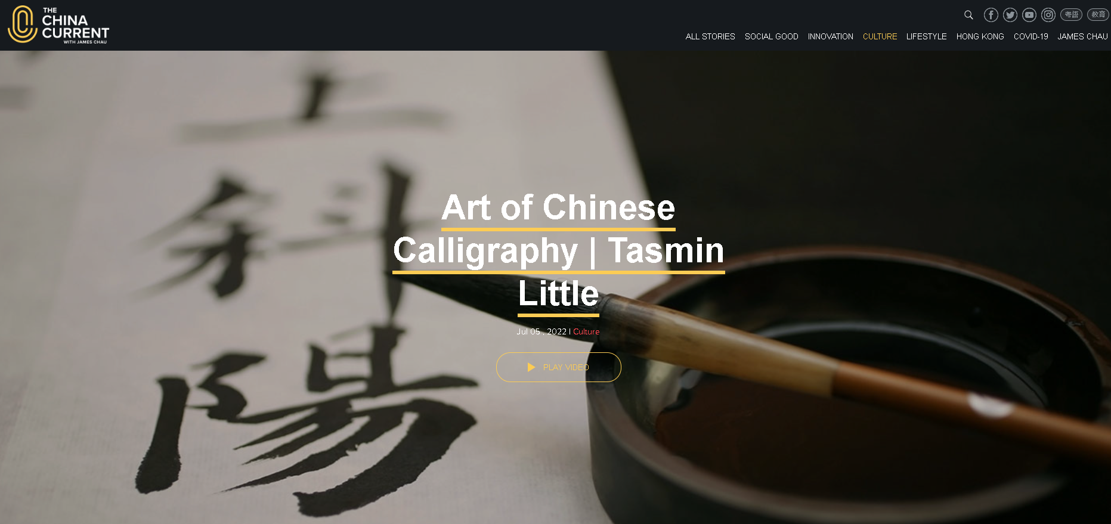

Do you like Chinese calligraphy? Do you like other forms of artwork? If yes, what are they? What makes a masterpiece of Chinese calligraphy/creative artwork? Think and share your ideas or experiences with your parents or classmates.

Read the Chinese story and answer the following questions.

Holding a Book in the Hand All the Time
1. During the Three Kingdoms Period*, there was a military general called Lu Meng. He was born into a poor family. He received little education when he was young. In his early years, he joined the army and fought in several battles. Despite his bravery and achievements in battles, he did not like reading. It was difficult for him to widen his knowledge.

2. Sun Quan, the King of Wu, recognised Lu Meng’s efforts in battles and encouraged him to further improve himself. The king said, “You are now the military leader. Try to read more military books and history books. These books help equip you with military knowledge and skills. In the future, I believe you can take on more responsibilities, make wiser decisions and protect our state.”

3. After listening to the king’s advice, Lu Meng held back and said, “My king, I have to handle a mountain of complicated issues in the army. I’m afraid I won't be able to spend time reading books.”

4. The king replied, “Lu Meng, to be honest, your workload is not as heavy as mine. Although I’m always fully occupied with our state’s affairs, I read every day. The more you read, the more military strategies you can learn and apply.”

5. Lu Meng asked, “My king, would you suggest some good books for me?”

6. The king smiled and recommended a range of books for him. He said, “You can first study some military classics such as Sun Tzu and Liu Tao, and then read some history books such as Zuo Zhuan and Records of the Grand Historian. You can learn from the past experience and broaden your horizons by reading these books. In the past, King Guangwu of Han always held a book in his hand, even when he was fighting in a war. Having insufficient time to read is just an excuse. It’s all about how you allocate your time.”

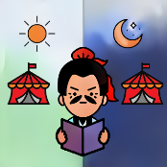
7. After that, Lu Meng understood the importance of reading. He persevered in studying military books and history books. Since then, he always held a book in his hand. He became a capable director general with remarkable intelligence. His incisive opinions on military issues impressed knowledgeable ones.

*The Three Kingdoms Period refers to the division of China among the states of Wei, Shu and Wu in a period of time (220 AD – 280 AD) in ancient Chinese history.

1. Lu Meng was a ________ during the Three Kingdoms Period.
a. king
b. scholar
c. teacher
d. general
Explanation/Hints:
Read paragraph 1.
“During the Three Kingdoms Period, there was a military general called Lu Meng.”

2. Lu Meng ________ because he did not like reading.
a. joined the army when he was young
b. was unable to enrich his knowledge
c. was courageous and fought in battles
d. had incisive opinions on military issues
Explanation/Hints:
Read paragraph 1.
“Despite his bravery and achievements in battles, he did not like reading. It was difficult for him to widen his knowledge.”

- Why did the King of Wu encourage Lu Meng to read more books?
It was because ________.
a. the king found out that Lu Meng had nothing to do when he was free
b. the king wanted to ask Lu Meng to help him deal with the state’s affairs
c. the king wanted Lu Meng to acquire more military knowledge and skills
d. the king wanted Lu Meng to be a proficient reader and writer in the future
Explanation/Hints:
Read paragraph 2.
“The king said, ‘You are now the military leader. Try to read more military books and history books. These books help equip you with military knowledge and skills.’ ”

- How did Lu Meng respond to the king’s advice?
a. He was hesitant.
b. He was excited.
c. He was amused.
d. He was grateful.
Explanation/Hints:
Read paragraph 3.
“After listening to the king’s advice, Lu Meng held back and said, ‘My king, I have to handle a mountain of complicated issues in the army. I'm afraid I won't be able to spend time reading books.’ ”

5. Which of the following descriptions are correct?
(i) Lu Meng’s workload was much heavier than the King of Wu’s.
(ii) The King of Wu recommended some good books to Lu Meng.
(iii) The King of Wu hoped that Lu Meng could gain insights through reading.
(iv) The King of Wu was too busy and did not spend any time reading books.
a. (i) & (ii)
b. (ii) & (iii)
c. (iii) & (iv)
d. (ii), (iii) & (iv)
Explanation/Hints:
Was Lu Meng’s workload much heavier than the King of Wu’s?
Did the king recommend any books to Lu Meng?
What did the king expect Lu Meng to gain through reading?
Did the king spend time reading when he was busy?

6. As advised by the king, reading military classics and history books could ________.
a. arouse Lu Meng’s interest in reading and help him learn better
b. help Lu Meng learn how to read and allocate the time better
c. help Lu Meng learn how to note down his battle experience better
d. help Lu Meng learn from the past and gain new knowledge
Explanation/Hints:
Read paragraph 6.
“He said, ‘You can first study some military classics such as Sun Tzu and Liu Tao, and then read some history books such as Zuo Zhuan and Records of the Grand Historian. You can learn from the past experience and broaden your horizons by reading these books.’ ”

- An adverb or adverbial phrase of frequency is used to describe the frequency of an action. For example, “In the past, King Guangwu of Han held a book in his hand all the time, even when he was fighting in a war.” “All the time” is used to describe the action (i.e. holding a book) without stopping at any time.

Read the following descriptions. Fill in each blank with an adverb or adverbial phrase of frequency from the list given. Each option can be used once only.

A. once in a while B. all the time C. often D. rarely

 | Description | Adverb / adverbial phrase of frequency
7a. | After listening to the king’s advice, Lu Meng read military books and history books ___________________ and therefore his opinions on military issues became incisive. | ( )
7b. | Lu Meng told the King of Wu that he ___________________ had time to read books because he needed to handle many issues in the army. | ( )
7c. | The King of Wu talked to Lu Meng ___________________ and encouraged him to improve himself through reading books. | ( )
7d. | The King of Wu ___________________ spent time reading although he was always busy dealing with the state’s affairs. | ( )

Explanation/Hints:
Read the sentences carefully to understand their meanings.

- Who always held a book in his hand when fighting in the war?
a. Sun Quan, the King of Wu
b. The soldiers of Wu
c. King Guangwu of Han
d. The soldiers of Han
Explanation/Hints:
Read paragraph 6.
“ ‘In the past, King Guangwu of Han always held a book in his hand, even when he was fighting in a war.’ ”

- How did reading books change Lu Meng?
a. He showed a good understanding of military issues.
b. He collected many military books and history books.
c. He did not want to express opinions on military issues.
d. He found that it was challenging to express good ideas.
Explanation/Hints:
Read paragraph 7.
“He became a capable director general with remarkable intelligence. His incisive opinions on military issues impressed knowledgeable ones.”

10. What is the moral lesson of the story? Based on the story, which Chinese saying can you think of?

Extension Activity

Watch the video clip “Chinese Culture in Africa’s Tanzania”, which is about a teacher from China called Li Ya Ya who shares her language, cuisine and culture with the young people in Tanzania, a country in East Africa.

https://chinacurrent.com/story/23805/chinese-culture-in-africas-tanzania

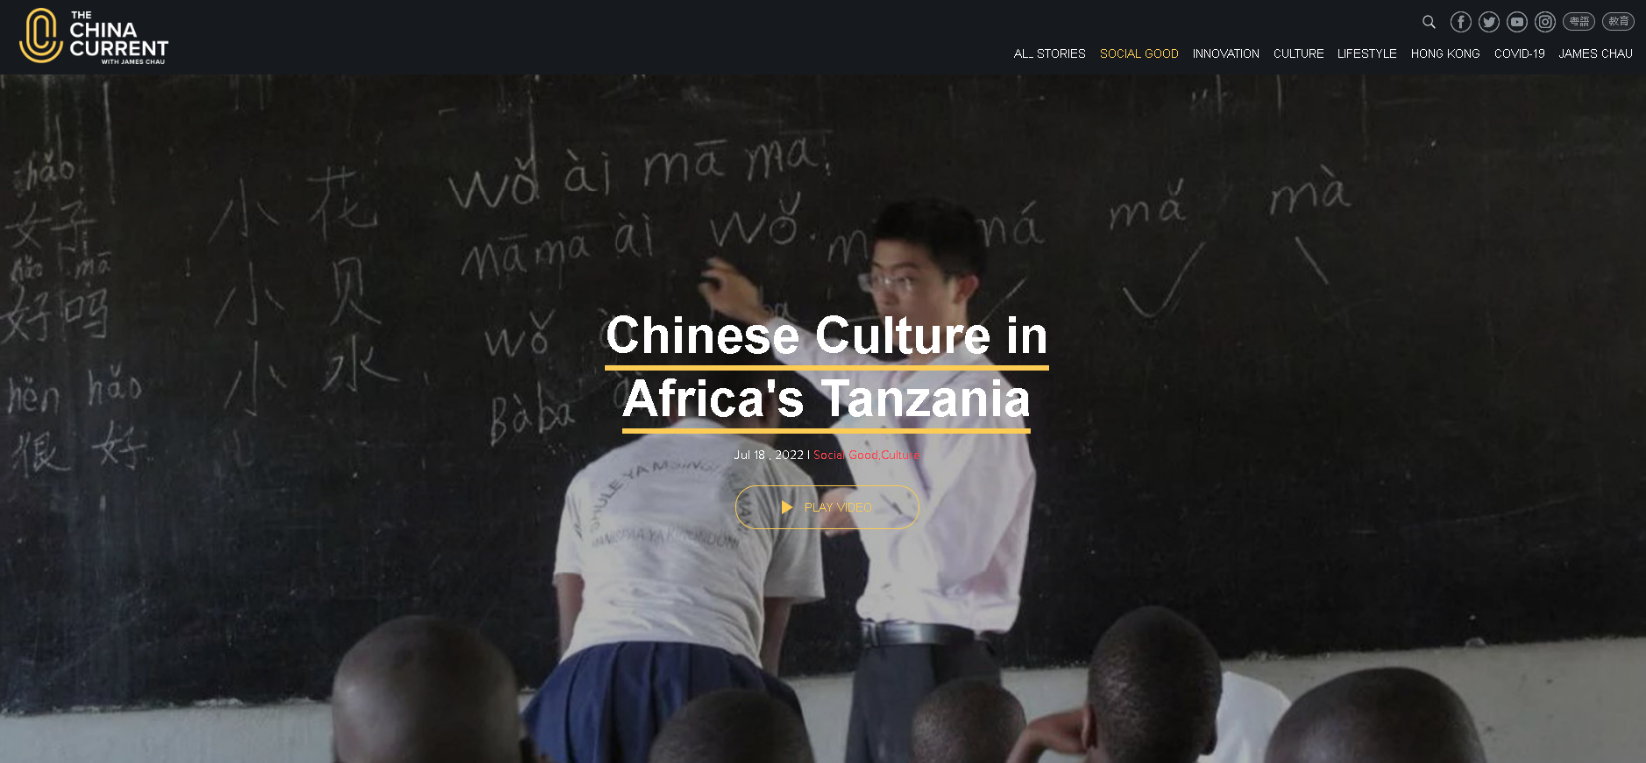

What does the teacher Ya Ya teach her students? How can the young people in Tanzania improve their lives after learning from Ya Ya? After reading the Chinese story and watching the video, can you tell the importance of education? How does reading influence your learning? Think and share your ideas or experiences with your parents or classmates.

Read the Chinese story and answer the following questions.

Quitting Halfway

1. During the Warring States Period*, there was a poor man called Le Yangzi. He lived with his wife in a small village.

2. One day, Le Yangzi saw a piece of gold near a roadside when he was heading back home. He picked it up at once and yelled happily, “How lucky I am! Let me give it to my wife and she must be thrilled!” He put the gold in a small box carefully and went back home. When he saw his wife, he told her about the gold and showed it to her. However, his wife was very sad. She talked to him gently, “I have heard people say ‘an upright person does not drink the water from a thief’s spring’. How can you bring this piece of gold home? Please put it back.” After listening to his wife’s words, he was extremely ashamed and took the gold back to the roadside. The next year, Le Yangzi left home to pursue his studies with his wife’s encouragement.

3. A year later, Le Yangzi suddenly returned home. He knocked at the door when his wife was weaving at home. She opened the door and was surprised to see Le Yangzi. “Have you finished your studies?” asked his wife in amazement. “I have learnt something but I have not finished yet,” murmured Le Yangzi embarrassedly. “I have been away for a year, so I come back to have a look at our house,” Le Yangzi replied.

4. After his wife heard this, she picked up a pair of scissors from a basket and cut the cloth that had been woven into two pieces. “I worked so hard to weave this cloth bit by bit, and now I have cut it. It means that my previous time and hard work are wasted,” said his wife earnestly. “It is the same with your studies. We can acquire knowledge only through diligence. Now you have stopped halfway. Isn’t it the same as cutting the cloth into half?” asked his wife.

5. Le Yangzi was moved by what his wife said. “I promise I will continue my studies,” he said. He then went back to school. A few years later, Le Yangzi became a famous scholar.
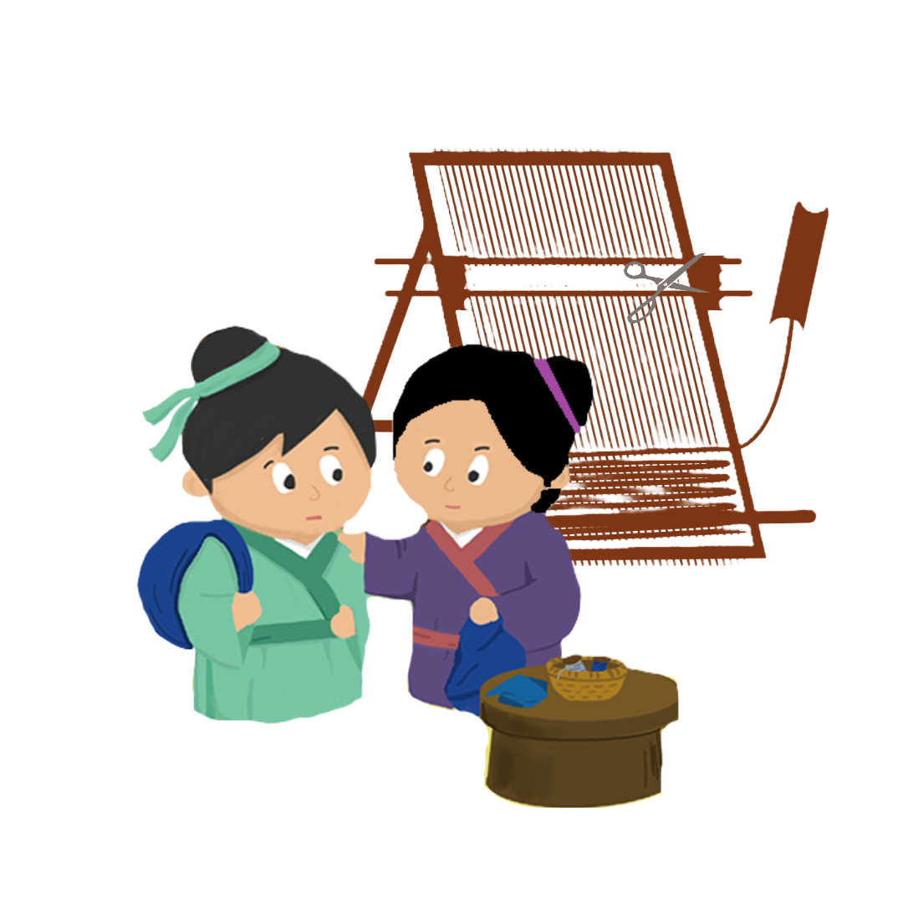

*The Warring States Period refers to a period of time (475 BC - 221 BC) in ancient Chinese history characterised by warfare.
- Where did Le Yangzi live?
- He lived in a house near a roadside.
- He lived in a small village.
- He lived next to a school.
- He lived in a big villa.
Explanation/Hints:
Read paragraph 1.
“During the Warring States Period, there was a poor man called Le Yangzi. He lived with his wife in a small village.”

- What did Le Yangzi find when he was returning home?
- He found a basket of gold.
- He found a bowl of gold.
- He found a box of gold.
- He found a piece of gold.
Explanation/Hints:
Read paragraph 2.
“One day, Le Yangzi saw a piece of gold near a roadside when he was heading back home.”

- How did Le Yangzi feel when he found the gold?
- He was worried.
- He was embarrassed.
- He was excited.
- He was moved.
Explanation/Hints:
Read paragraph 2.
“He picked it up at once and yelled happily, ‘How lucky I am! Let me give it to my wife and she must be thrilled!’ ”

- How did Le Yangzi’s wife feel when she saw the gold?
- She was unhappy.
- She was thrilled.
- She was ashamed.
- She was moved.
Explanation/Hints:
Read paragraph 2.
“However, his wife was very sad.”

- What did Le Yangzi’s wife ask her husband to do then?
- She asked her husband to sell the gold.
- She asked her husband to put the gold back.
- She asked her husband to bury the gold.
- She asked her husband to keep the gold at home.
Explanation/Hints:
Read paragraph 2.
“ ‘How can you bring this piece of gold home? Please put it back.’ ”

- The wife quoted “an upright person does not drink the water from a thief’s spring”. What is “an upright person” like? An upright person is ___.
- tall and confident
- friendly and cheerful
- honest and responsible
- persistent and hard-working
Explanation/Hints:
What is a thief?
Do you think a good person would drink the water from a thief’s spring?
What did Le Yangzi’s wife ask her husband to do with the gold?
What kind of person did she want her husband to be?

- Speaking verbs are verbs such as “say” or “ask” which we use to report what someone said. These verbs have more specific meanings and give readers more information about the thoughts and feelings of the characters.

Read the following descriptions. Fill in each blank with a speaking verb from the list given. Each option can be used once only.

- yelled B. questioned C. promised D. murmured

 | Description | Speaking verb
7a. | “I will finish my studies before I return home again,” _________ Le Yangzi. | ( )
7b. | “How lucky I am to have this piece of gold!” _________ Le Yangzi. | ( )
7c. | “I am sorry that I have not yet completed my studies,” _________ Le Yangzi. | ( )
7d. | “Why do you return home without completing your studies?” __________ Le Yangzi’s wife. | ( )

Explanation/Hints:
Read the sentences carefully to understand their meanings.

8. What did Le Yangzi’s wife do at home?
a. She taught students at home.
b. She cooked food for her neighbours.
c. She grew vegetables at home.
d. She wove cloth at home.
Explanation/Hints:
Read paragraph 4.
“ ‘I worked so hard to weave this cloth bit by bit, and now I have cut it. It means that my previous time and hard work are wasted,’ said his wife earnestly.”

9. What did Le Yangzi do after listening to his wife’s response?
a. He continued to pursue his studies.
b. He gave up his studies.
c. He started his business.
d. He continued to work in a school.
Explanation/Hints:
Read paragraph 5.
“Le Yangzi was moved by what his wife said. ‘I promise I will continue my studies,’ he said. He then went back to school. A few years later, Le Yangzi became a famous scholar.”

10. What is the moral lesson of the story? Based on the story, which Chinese saying can you think of?

Extension Activity

Watch the video clip “Climbing to a New Future”, which is about how a Chinese clifftop village, Atulie’er, has changed after a steel staircase of 2,600 feet was built.

https://chinacurrent.com/story/19916/climbing-to-a-new-future

Building a steel staircase of 2,600 feet on a cliff was a big challenge but people finally made it. What have you learnt from them? Think and share your ideas or experiences with your parents or classmates.

Read the Chinese story and answer the following questions.

Sending Goose Feathers from Thousands of Miles Away
1. During the Tang Dynasty*, the King of Huihe wanted to maintain a friendly relationship with the Tang Dynasty, so he sent his messenger, Mian Bogao, to visit the King of Tang and bring national treasures to him. The most precious one was the rare white goose.

2. On the way, Mian Bogao was distressed and restless. He thought, “If I lost the white goose, how could I explain it to my king?” Therefore, he kept an eye on the white goose and took good care of it.

3. Having walked for over a mile, Mian Bogao came to the Mianyang River. He wanted to bathe the white goose, so he opened the cage and put the white goose into the water carefully. All of a sudden, the white goose spread its wings. He jumped forward quickly and wanted to catch the white goose. Unfortunately, he could only pluck a few goose feathers and the white goose flew away.

4. Mian Bogao was very anxious as he did not know how to tell the King of Tang that he had lost the white goose. He beat his chest and burst into tears. One of the servants told him, “The white goose has already gone. It is meaningless to cry and feel sorry. Let’s think of a solution together.”

5. A solution popped up in Mian Bogao’s head. He decided to continue the journey. He took out a piece of pure white silk and carefully wrapped the goose feathers. Then he wrote a few lines on the silk:
“As I have lost the white goose on the way, it is difficult to return home.
May I ask the King of Tang to accept my heartfelt apologies?
These goose feathers are light but they are sent from afar and with the best wishes.”

6. Finally, Mian Bogao came to Changan, the capital of the Tang Dynasty, with jewellery and the goose feathers. He met the King of Tang and presented the king with the gifts. After the king opened a little bag, he saw the few goose feathers and read the lines on the white silk. The king listened to his explanation. At last, the king forgave him for having lost the white goose and rewarded his honesty with appreciation. He returned home with great joy.
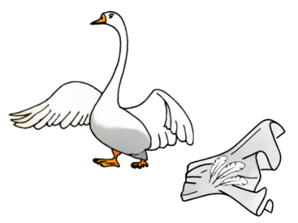

*The Tang Dynasty refers to a dynasty in ancient Chinese history that ruled from 618 AD to 907 AD.
- Who was Mian Bogao?
Mian Bogao was ________.
a. the King of Huihe
b. the King of Tang
c. a treasure hunter in the State of Tang
d. a messenger in the State of Huihe
Explanation/Hints:
Read paragraph 1.
“During the Tang Dynasty, the King of Huihe wanted to maintain a friendly relationship with the Tang Dynasty, so he sent his messenger, Mian Bogao, to visit the King of Tang and bring national treasures to him.”

- Why did the King of Huihe ask Mian Bogao to send national treasures to the King of Tang?
The King of Huihe ________.
a. treasured the friendship with the King of Tang
b. planned to end the friendship with the King of Tang
c. wanted the King of Tang to visit him
d. would like to have treasures from the King of Tang in return
Explanation/Hints:
Read paragraph 1.
“During the Tang Dynasty, the King of Huihe wanted to maintain a friendly relationship with the Tang Dynasty, so he sent his messenger, Mian Bogao, to visit the King of Tang and bring national treasures to him.”

- How did Mian Bogao feel when he was on the way to the State of Tang?
Mian Bogao was ________.
a. angry
b. cheerful
c. worried
d. shy
Explanation/Hints:
Read paragraph 2.
“On the way, Mian Bogao was distressed and restless. He thought, ‘If I lost the white goose, how could I explain it to my king?’ ”

4. What did Mian Bogao do when he arrived at the Mianyang River?
a. He swam in the river and left the cage near the river.
b. He played with the white goose in the river.
c. He opened the cage and wanted to wash the white goose in the water.
d. He hugged the white goose tightly to his chest.
Explanation/Hints:
Read paragraph 3.
“Having walked for over a mile, Mian Bogao came to the Mianyang River. He wanted to bathe the white goose, so he opened the cage and put the white goose into the water carefully.”

5. Which of the following descriptions is correct?
a. The white goose flew away and Mian Bogao could only grab a few goose feathers.
b. Mian Bogao was happy to let the white goose practise flying.
c. Mian Bogao could catch the white goose when it attempted to fly away.
d. The white goose kept spreading its wings and enjoyed swimming in the river.
Explanation/Hints:
Read paragraph 3.
“All of a sudden, the white goose spread its wings. He jumped forward quickly and wanted to catch the white goose. Unfortunately, he could only pluck a few goose feathers and the white goose flew away.”

6. What did Mian Bogao’s servant do after the white goose flew away?
a. Mian Bogao’s servant beat his chest and burst into tears.
b. Mian Bogao’s servant encouraged Mian Bogao to find a way to solve the problem.
c. Mian Bogao’s servant thought crying was useful for getting the white goose back.
d. Mian Bogao’s servant kept running and helped Mian Bogao find the goose.
Explanation/Hints:
Read paragraph 4.
“One of the servants told him, ‘The white goose has already gone. It is meaningless to cry and feel sorry. Let's think of a solution together.’ ”

- Suffixes are letters which we add at the end of a word to make a new word. The new word is often a different word class from the original word. The suffix “-less” is added to nouns to form adjectives meaning “without something”.

Read the following descriptions. Fill in each blank with an adjective from the list given. Each option can be used once only.

A. careless B. hopeless C. restless D. meaningless

 | Description | Adjective
7a. | While the white goose was spreading its wing, Mian Bogao was cleaning the cage. He was so ________________ as he did not keep an eye on the white goose. | ( )
7b. | Mian Bogao was _______________ as he needed to take good care of the precious white goose. | ( )
7c. | Mian Bogao’s servant told Mian Bogao that crying was _______________ and he needed to fix the problem. | ( )
7d. | Having lost the white goose, Mian Bogao did not know what to do and was _______________. | ( )

Explanation/Hints:
Read the sentences carefully to understand their meanings.

- What did Mian Bogao do to fix the problem?
a. Mian Bogao went back to the State of Huihe and explained the situation to the king.
b. Mian Bogao returned to the Mianyang River and waited for the white goose to come back.
c. Mian Bogao returned to the State of Huihe to get another white goose for the King of Tang.
d. Mian Bogao sent goose feathers together with a few lines of explanation as a gift.
Explanation/Hints:
Read paragraph 5.
“A solution popped up in Mian Bogao’s head. He decided to continue the journey. He took out a piece of pure white silk and carefully wrapped the goose feathers. Then he wrote a few lines on the silk.”

9. Why did the King of Tang not punish Mian Bogao at last?
a. The King of Tang liked jewellery very much and forgave Mian Bogao.
b. The King of Tang thought Mian Bogao was honest.
c. The King of Tang did not want the white goose, so he forgave Mian Bogao.
d. The King of Tang liked the goose feathers and forgave Mian Bogao.
Explanation/Hints:
Read paragraph 6.
“At last, the king forgave him for having lost the white goose and rewarded his honesty with appreciation.”

10. What is the moral lesson of the story? Based on the story, which Chinese saying can you think of?

Extension Activity

Watch the video clip “The Legend of Moon Cakes”, which is about the history and legends of the Mid-Autumn Festival, one of the important festivals in the Chinese lunar calendar for sending our warmest wishes to families and friends.

https://chinacurrent.com/story/23958/the-legend-of-moon-cakes-mid-autumn-festival-tasmin-little

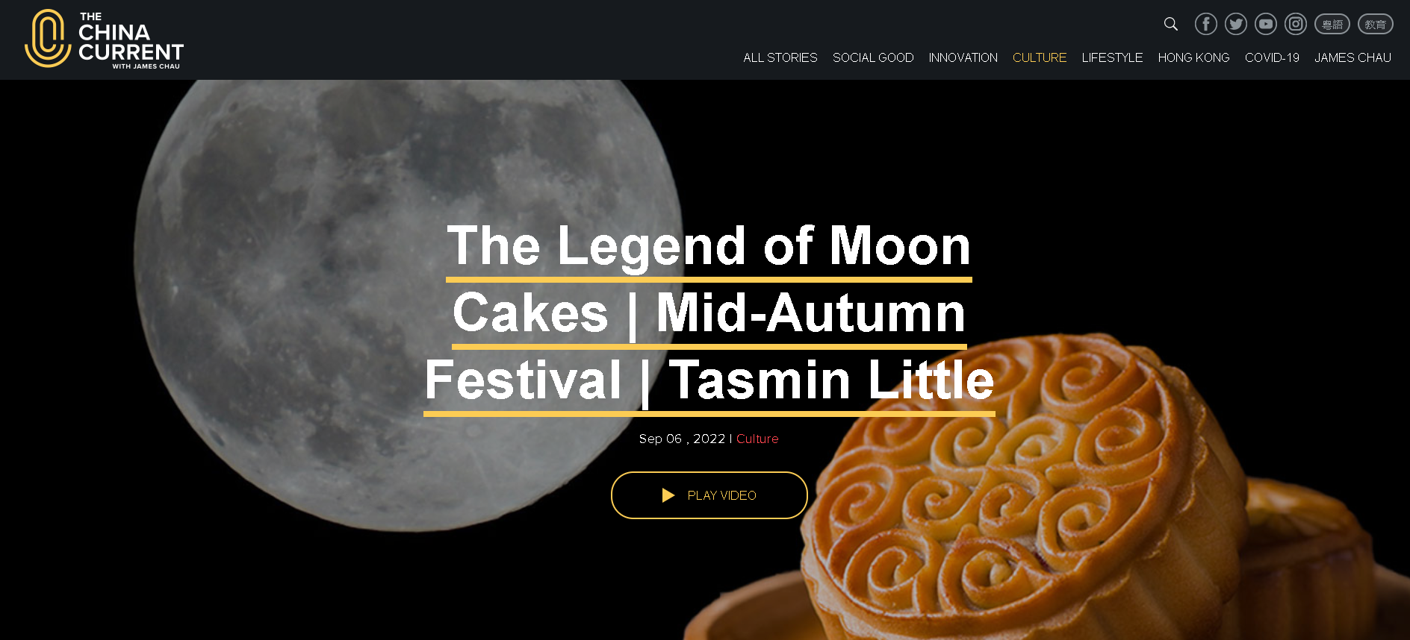

When your friend gives a gift to you, is the price of the gift the most important? Why? Think and share your ideas or experiences with your parents or classmates.

